Setting Up Application Environment

Create an Account in Sendgrid

|  |  |
| --- | --- |
| Date | 29 OCT 2022 |
| Team ID | PNT2022TMID13904 |
| Project Name | Containment Zone Alerting Application |

# Step 1:

Go to ofﬁcial Sendgrid website:

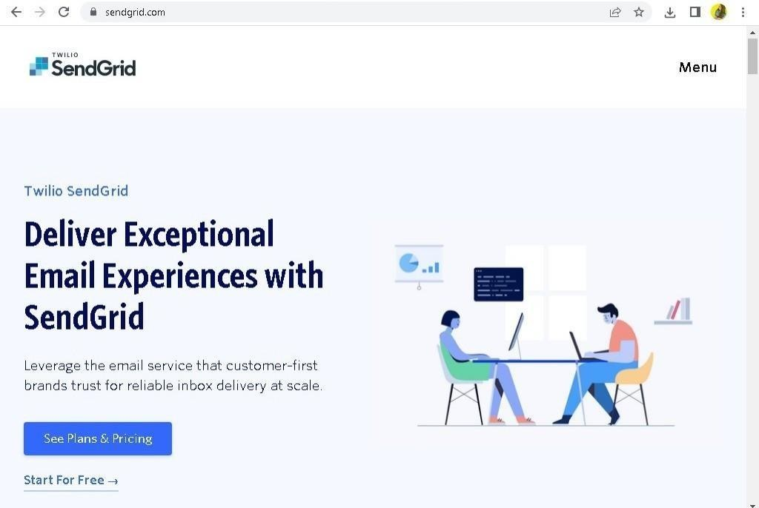

# Step 2:

Then go to Registration Page, you need to give all the details required for creating a Sendgrid account and ﬁnally click create button. The below screenshot will show the registration Process.

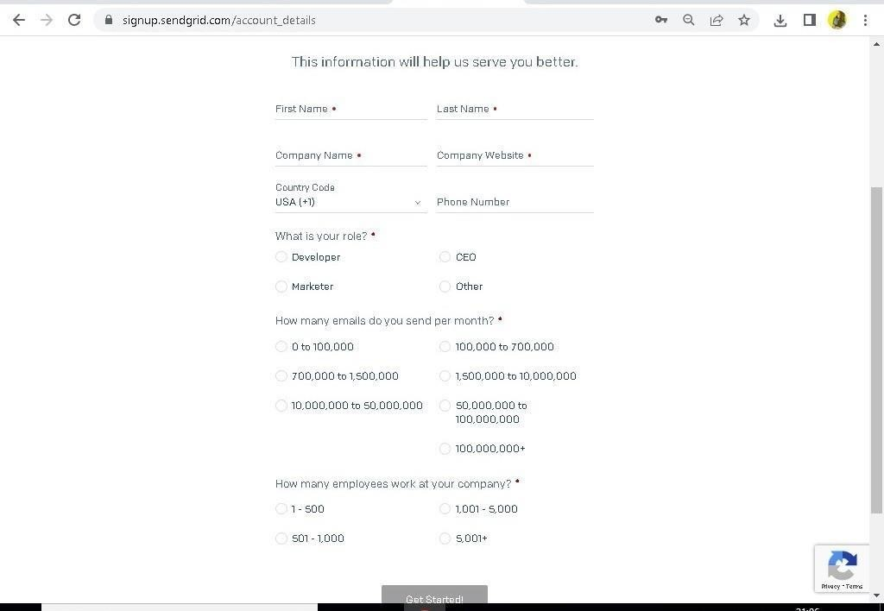

# Step 3:

Then it will redirect you to a home page of your sendgrid account.



# Step 4:

Finally, you have created your account and now you can access the sendgrid account.